/Field Education: Investing in Student Learning & Strengthening Communities
The WVU School of Social Work develops leaders in solving the most demanding social issues of our day through rigorous research, academic innovation and public service. Students are empowered to extend their reach, deepen their impact, and engage in real-world social change. They learn to critically analyze personal, familial, and environmental factors affecting practice settings and practice techniques, and to advocate for those in need in achieving their fullest potential. Our programs prepare students for careers as professional social workers committed to public service in nonprofits, government, education, business, and higher education. We are building the leaders and change agents of tomorrow today.
Field instruction is an integral part of the total curriculum and the signature pedagogy of Social Work. Field experiences provide students with the opportunity to apply the concepts and theories learned in the classroom to real practice situations, thus incorporating the knowledge, values, and skills that they have studied into their work with actual clients, communities, and systems.
/Paying It Forward: How Agencies, Students, and Communities Benefit From Field Partnerships
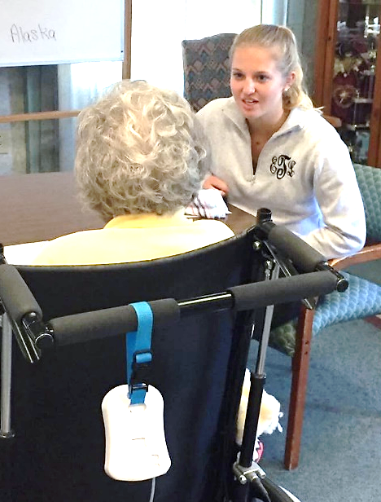
- Field Instructors are able to “pay it forward” as a fellow social worker and play a vital role in the education and training of a new colleague.
- Partnerships create relationships with motivated students that can assist with program activities, as well as explore, research, and develop agency “wish list” items, such as outcome evaluations, outreach, and new community resources.
- Agencies experience increased organizational capacity, enhanced quality in services, and a pipeline for new employees with existing agency training.
- Agencies and Field Instructors gain a formal WVU affiliation as approved placement sites and Field Faculty, with access to information regarding new evidence-based interventions and methods, community resources, policy issues, and other relevant areas.
- Field Instructors gain enhanced professional supervision skills and are provided free Continuing Education programs in Field Education related areas.
- Everyone gains exposure to new ideas, perspective, and renewed energy!

/What We Seek from Agencies for Amplified Learning and Impact
- A safe, ethical, and professional learning environment where students can engage in a variety of social work roles and practices, such as brokering, advocacy, service coordination, counseling, education, and mobilization.
- Trained and credentialed staff to provide quality supervision and appropriate social work learning activities and experiences.
- Time allowance for Field Instructors and/or Site Supervisors to attend field instructor orientation training and field education refresher sessions.
- Timely communication with the field education team regarding any problems, concerns, or barriers which may negatively impact the student’s placement.
- Diverse agency settings in Morgantown, WV and throughout the region.
/Key Roles in Field Education Experiences
Field Instructors & Placement Agency: The Field Instructor is a teacher, a role model, and serves as the representative of the field placement site, regardless of whether they are on site or external to the agency. The agency provides a conducive environment for appropriate learning experiences that enables the student to develop and integrate theoretical concepts with practice skills. Field Instructors help develop and implement the learning contract and placement schedule, and also provide weekly, hour-long supervisory sessions and continuous assessment of the student's level of knowledge, educational needs, capabilities, and interests. Field Instructors must have either a BSW or MSW from an accredited Social Work Program and a minimum of 2 years post Degree work experience to supervise BSW and MSW students, respectively.
Students: The student has the main responsibility for their own learning. They are expected to actively participate in the planning and implementation of the field instruction experience, and expected to maintain the same ethical standards and practices as professional staff.
WVU Faculty Field Liaisons: The Faculty Field Liaison is the main WVU agency contact and they engage in the design, implementation, and evaluation of the student placement. They are also the instructors for students’ professional seminar. Liaisons join with the Field Instructor and student in assessing student progress, award the student’s final field grade, and serve as the first point of contact in situations where problems occur in field learning.
Site Supervisors: The Site Supervisor serves an on-site, professional staff person that provides primary supervision for the student when a qualified Field Instructor is not on-site. They must be knowledgeable about the agency setting, its programs, policies, intervention strategies and tactics; social work roles and functions; and must be willing to and have the time for undertaking the on-site teaching role.

/Field Education Experiences: Placement Types & Details
Foundation-Generalist Placement (BSW & MSW)  Students learn to apply generalist engagement, assessment, intervention, and evaluation skills. They develop an understanding of responding to social and human problems within a context of social work values and ethics, social justice, and affirmation of the human rights of diverse groups of people.  BSW: Utilizing a block placement model for 15 weeks in their final semester, students are in their agency 3-4 days a week for 24-28 hours, plus weekly seminar attendance. 340 required hours**.  MSW: Beginning in Fall and Summer semesters, students are in agencies 14-20 hours per week for around 20 weeks and attend professional seminars. 255 required hours**.  *Part-time/Online students; 12-16 hours per week/25 weeks.  ** Reflects COVID-19 reduction in hour requirements | Specialized-Advanced Placement (MSW only)  Building on course work and the Foundation-Generalist placement, students learn to apply advanced integrated practice skills, engage with interdisciplinary teams, and to concentrate more intensively and autonomously on micro, mezzo, and macro levels of intervention as they prepare to enter the social work career field.  Regular Standing MSW: Usually across Fall and Spring semesters of their second year for around 30 weeks, students are in agencies 18-24 hours per week and attend professional seminars. 510 required hours**.  Advanced Standing MSW: Occurring Fall thru Spring semesters of the one year MSW program, students are in agencies 18-24 hours per week for around 30 weeks and attend professional seminars. 510 required hours**.  *Part-time/Online students; 16-20 hours per week/ 37 weeks.  ** Reflects COVID-19 reduction in hour requirements

