Strength-Based Grant Writing for Nonprofit Organizations
with Alice Ruhnke and Trish Hatfield

September 23-25, 2015
NiSource Building, Charleston

Sponsored by Volunteer West Virginia

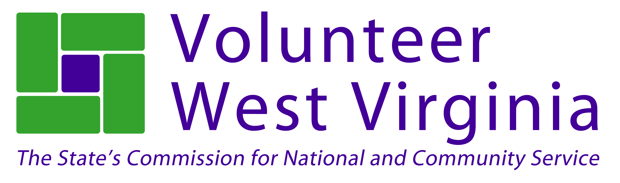

Strength-Based Grant Writing is intended to help build new capacity for nonprofit organizations. This hands-on, intensive training will help aspiring and experienced grant writers approach grant writing from a strength-based perspective. Strength-based grant writing seeks collaboration, shared understanding, and commitment to action by the organization and the larger community in identifying opportunities for change and new direction. At the end of this training, participants will not only understand all the components of a grant application, but will also have a new way of looking appreciatively at what works in their organization and community.

More than 350 people have attending this workshop since its inception. One participant recently wrote:

I had the absolute pleasure of participating in your Strength Based Grant Writing Workshop this past October. I cannot express to you how extraordinary and worthwhile I found the entire process.
So far, my organization has been approved for two of the grants that I have written - there is no doubt in my mind this would not have been feasible without the tools and knowledge I gained through your workshop.”

Come and join the growing network of nonprofit professionals approaching grant writing from this unique and energizing perspective. Registration is limited to the first 50 people.

We will be asking questions such as:
- What are our organization’s strengths? What can we build on? What makes us unique? How do we use our strengths to get results?
- What are our stakeholders asking for? How can we reframe challenges to be seen as exciting opportunities? What new skills do we need to move forward?
- What do we care deeply about? What do we want more of? What strategic initiatives would support our aspirations?
- What meaningful measures would indicate that we are on track to achieving our goals?
What resources are needed to implement our most vital projects?

WVU Continuing Education Certificate in Nonprofit Management
This training is approved for the WVU Continuing Education Certificate in Nonprofit Management. All hours completed during the three days can be counted towards the certification. For more information or to enroll in the program you can visit http://socialwork.wvu.edu/continuing-education/continuing-education-certificate-in-nonprofit-management or contact Jacki Englehardt at 304-293-3280, jacki.englehardt@mail.wvu.edu

Training Times
September 23: 10am-5:00pm
September 24: 9am-5:00pm
September 25: 9am-12:30pm

Cost
Registration is $199 per person. This fee covers all materials, lunch on Wednesday and Thursday and breaks each day. Members of the West Virginia Non-Profit Association are eligible to attend at a discounted rate of $149. Please make checks payable to Volunteer West Virginia. We would be happy to send an invoice if that is more convenient for you or your organization. We are unable to accept credit card payments.

Lodging
A block of rooms has been reserved at the Holiday Inn Express, 100 Civic Center Drive, Charleston WV 25301. If you would like to be included on our room list and have the lodging cost added to your invoice, please indicate this on your registration form.
To make your own reservation at the $105 rate, you must book by August 23rd. Use code GWT when booking. Call: 855.729.5133 or book online: Lodging for Grant Writing Training

Instructors
Alice Ruhnke - If Alice had to pick one word to describe the essence of her small business, the choice would be simple: Storytelling. The Grant Advantage assists nonprofit organizations working to make real change in their communities by identifying an organization’s strengths, clarifying its goals, measuring its impact, and effectively telling its story in the form of grant writing.
Alice’s enthusiasm for what she does is infectious! Those that train with her, leave with the skills and the confidence to tackle grant writing and tell their story. Alice has the gift to make what could be a heavy topic interesting, enjoyable and easy to understand.
Since 2006, The Grant Advantage has secured more than $5 million from federal, state, corporate, and foundation sources to help nonprofit organizations working in West Virginia and surrounding states have a greater impact on the communities they serve. In addition to grant writing, The Grant Advantage assists clients by locating funding sources, training individuals in all aspects of grant writing, facilitating Appreciative Inquiry strategic change sessions, conducting qualitative evaluations, and much more. A native of Omaha, Nebraska, Alice is married to Tim and has two amazing sons, Michael and Luke.
www.thegrantadvantage.net

Trish Hatfield, president of CharacterEthics, helps people heighten performance, nurture discoveries, improve communication, encourage shared leadership, shepherd change, and strengthen the capacity for critical thinking. She’s been at this for 30+ years, primarily as a trainer or facilitator in nonprofit organizations using strategies learned from Appreciative Inquiry, Skilled Facilitator, Facilitator U and the University of Wisconsin, Non-Violent Communication, not to mention the abundant wisdom of colleagues and clients. She has a MA in Humanities and also works part time as program assistant for Marshall University Graduate Humanities Program. She’s also a reasonable contra dancer. www.characterethics.com

Questions?
Please contact Moya Doneghy at 304-558-0111 or moya.doneghy@wv.gov.

