
Strength-Based Grant Writing for Nonprofit Organizations
with Alice Ruhnke and Trish Hatfield

April 17-19, 2013
NiSource Building, Charleston

Sponsored by Volunteer West Virginia

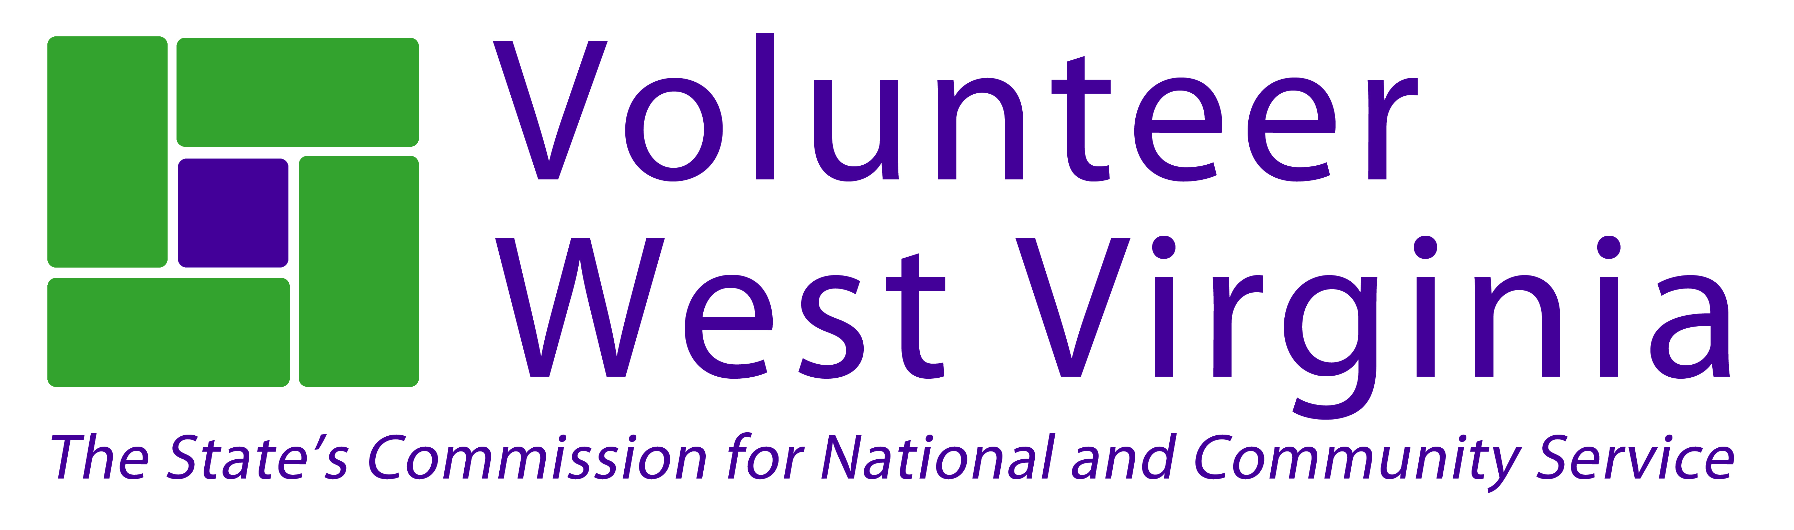

Volunteer West Virginia is pleased to sponsor Strength-Based Grant Writing training, which is intended to help build new capacity for nonprofit organizations. Participants will learn the nuts and bolts of preparing a grant proposal while being guided through a process that focuses on strengths and seeks to include stakeholders throughout the entire grant writing process.

At the end of this training, participants will not only understand all the components of a grant application, but will also have a new way of looking appreciatively at what works in their organization.

This hands-on, intensive workshop will help aspiring and experienced grant writers approach grant writing from a strength-based perspective. Strength-based grant writing seeks collaboration, shared understanding, and commitment to action by the organization and the larger community in identifying opportunities for change and new direction.

We will be asking questions such as:
- What are our organization’s strengths? What can we build on? What makes us unique?
How do we use our strengths to get results?
- What are our stakeholders asking for? How can we reframe challenges to be seen as exciting opportunities? What new skills do we need to move forward?
- What do we care deeply about? What do we want more of? What strategic initiatives would support our aspirations?
- What meaningful measures would indicate that we are on track to achieving our goals?
What resources are needed to implement our most vital projects?

Cost
Registration is $199 per person. This fee covers all materials, lunch and breaks each day.
Please make checks payable to Volunteer West Virginia and include with your completed registration. If you need an invoice, please let us know. Registration is limited to the first 50 people.

Members of the West Virginia Non-Profit Association are eligible to attend at a discounted rate of $100.

Instructors
Alice Ruhnke, the founder and chief operating officer of The Grant Advantage, works with nonprofit organizations to help them increase their organizational capacity and secure funding.
www.thegrantadvantage.net
Trish Hatfield, president of CharacterEthics, helps people build skills, co-create solutions, and explore tough issues that lead to better performance as individuals and communities.
www.characterethics.com

Strength-Based Grant Writing
April 17-19, 2013
NiSource Building, Charleston
Registration Form – Complete and return by April 10, 2013

Name: ____________________________________________________________________________________

Organization: ______________________________________________________________________________

Address: ______________________________________________________________________________

City: ___________________________________ State: _________ Zip: __________________________

Daytime Phone: _________________________ County: _____________________________________________

Email: _____________________________________________________________________________________

Registration @ $199

WV Non Profit Association member @ $100

Amount Enclosed: _______________________ Please Invoice:

Special Requests: ___________________________________________________________________

Send registration form and check to:
Volunteer West Virginia,
Grant Writing Training
710 Central Avenue, Charleston, WV, 25302
Questions? Call Moya Doneghy at 304-558-0111 – Moya.Doneghy@wv.gov

