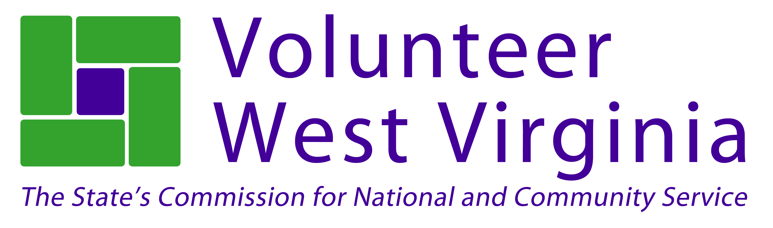

Strength-Based Grant Writing
April 8-10, 2014
Clarion Hotel, Fairmont
930 East Grafton Road, Fairmont, WV26554
Complete and return by March 31, 2014

Name: ______________________________________________________________________________

Organization: ________________________________________________________________________

Address: ________________________________________________________________________

City: _____________________________ State: _________ Zip: __________________________

Phone: ______________________________ County: _______________________________________

Email: ______________________________________________________________________________

Registration @ $199 WV Non Profit Association member @ $149

Lodging at the Clarion is available for $79 per night.

Please add me to the room list at the Clarion: April 8 April 9

Amount Enclosed: _______________________ Please Invoice:

Special Requests: ___________________________________________________________________

Training times:
April 8: 10am-5:00pm
April 9: 9am-5:00pm
April 10 9am-12:30pm

Send registration form to:
Volunteer West Virginia,
Grant Writing Training
710 Central Avenue, Charleston, WV, 25302

Questions? Call Moya Doneghy at 304-558-0111 – Moya.Doneghy@wv.gov

